
Submitted By :
NAME : Muhammad Mubashir
PROGRAM : BS
SEC & SEM: B & 2
ID : IBSE-22S-084
COURSE : Software Engineering
DEPARTMENT : Software Engineering
Submitted To :
Miss Syeda Wajiha Naim
Sindh Madressatul Islam University Karachi

Sindh Madressatul Islam University
Department of Software Engineering
2nd Semester Fall 2022
Course: Software Engineering
Faculty Name: Syeda Wajiha Naim

Assignment # 2
Deadline
Assignment must be submitted by 15th November 2022.
Objective
This assignment is meant develop understanding of SCRUM.
Assignment
A SCRUM team is developing a website for a clothing business. The website not only have components for company’s introduction, business line, but also for shopping compound their products. The development team will have to design and develop online shopping components for them as well. Do the following for this situation.
- List down high-level requirements for this project.
- The project duration has been estimated to be 5 months on the basis of high-level requirements. First break them into low - level ones (modules) and design a SCRUM for this project. For this you will have to:

- List down Scrum roles.
- List down product backlog items.
- Break up project into sprints.
- Design sprint with listing sprint backlog items.
- Do sprint planning [How long will this sprint go?]
- List down what is being discussed in Daily Scrum?
- What will your team discuss in Sprint Review Meeting?
- What are the points discussed in during Sprint Retrospective.?
Instructions:
  - To be submitted on 15th November 2022.
  - Use of rephrasing tools is prohibited.

SCRUM
Introduction
One of the most popular agile methodology. Scrum is a lightweight, iterative (step by step) and incremental frame (incremental model).Scrum break down the development phases into stages or cycles called “SPRINT”.The Development time each sprint is maximized and dedicated, there by managing only one sprint at a time.Scrum team has scrum master and product owner with constant communication the daily basis.
1. High-level requirements for this project
A project's high-level requirements are the fundamental information that its stakeholders use to authorize and establish a project starting point.High-level planning is focusing on establishing your project's requirements and deliverable and then tracking them over time. It's different from a detailed project plan, consisting of all the tasks needed to complete the project. One could say that a high-level plan is a manager's view of the project.

Requirements List for a project
The 6-step requirements gathering process
Step 1: Assign roles. The first step in requirements gathering is to assign roles project. ...
Step 2: Meet with stakeholders. ...
Step 3: Gather and document. ...
Step 4: List assumptions and requirements. ...
Step 5: Get approval. ...
Step 6: Monitor progress.

a) List down Scrum roles
Three scrum rules
3 roles: Product Owner, Scrum Master and the Team.5 events: Sprint, Sprint Planning, Daily Scrum, Sprint Review and Sprint Retrospective. 3 artifacts: Product Backlog, Sprint Backlog and Increment.

The three key Scrum roles
Each Scrum team has three key roles:
- The product owner role
- The Scrum Master role
- The development team member
Most important role in Scrum
One of the most important things for the success of scrum is the role of the Product Owner, who serves as an interface between the team and other involved parties (stakeholders).
PRODUCT OWNER
The Product Owner is basically the owner of the product itself that the customer needs to interact with, so the Product Owner creates the back end and provides all the details etc.

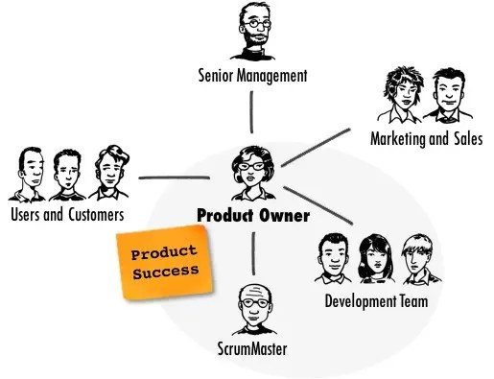
SCRUM MASTER
The Scrum Master is managing both the client and the team work. If there is a problem with the team or the client is coming, then he is managing both without telling anyone else. He is doing the wave alone, that's why he is called scrum master.
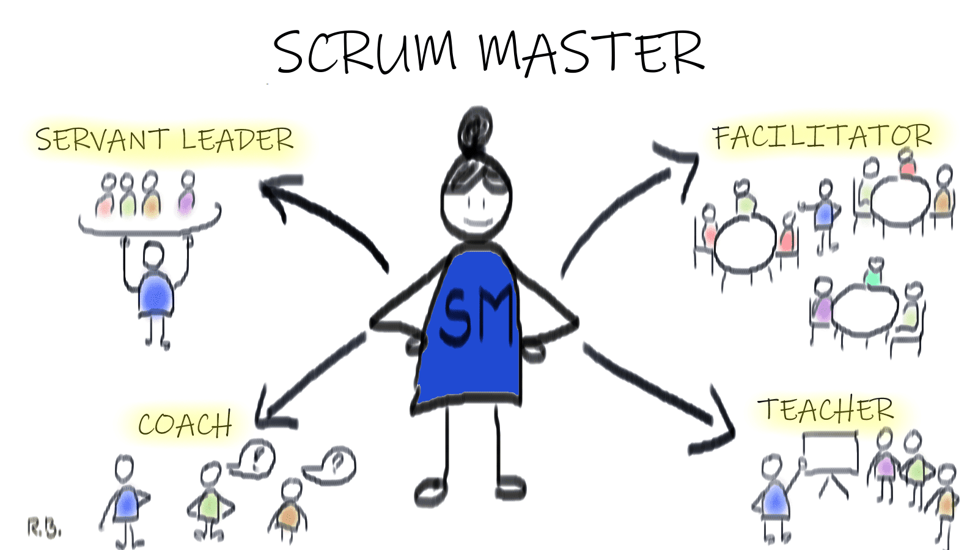

Development team member
The development team is a group of individuals (developers) who develop the product during each sprint. The team works together to deliver the final product to the stakeholders.
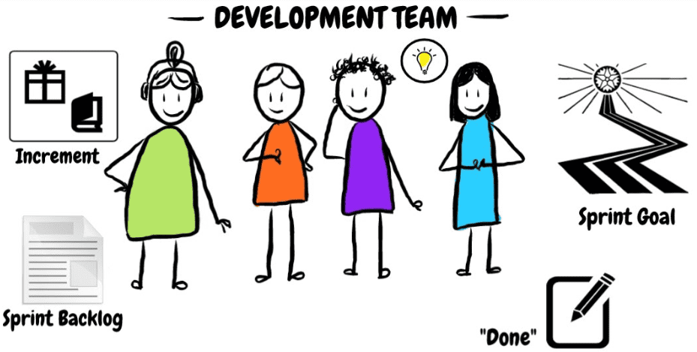

b)List down product backlog items
Three types of Backlog

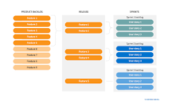

What are the types of backlog?
- Product backlog: Features you want to implement but have not yet prioritized for release.
- Release backlog: Features that need to be implemented for a particular release.
- Sprint backlog: User stories that need to be completed during a specific period of time.
Backlog
we do not have to design etc., all the basic requirements etc., whatever we do and whatever implementation etc. we do in it, we do it in this and after seeing this, we Continue to work.
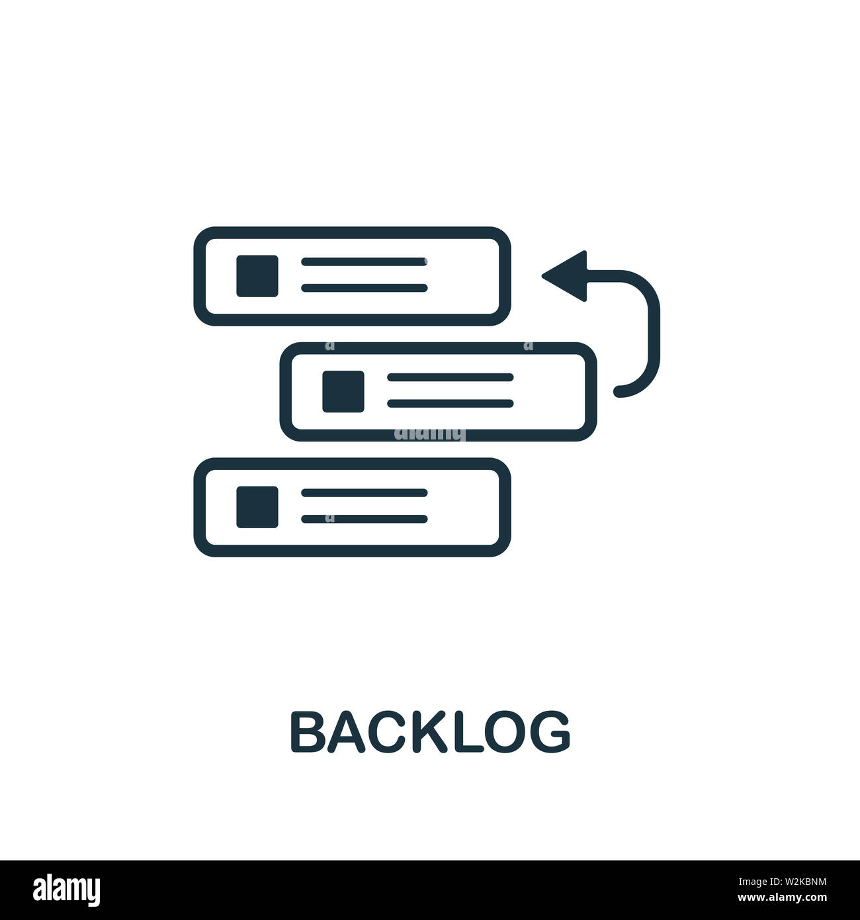

Product Backlog
In agile development, a product backlog (often referred to simply as a backlog) is a list of all things new features, bug fixes, improvements, changes to existing features, and other product initiatives that product teams must prioritize and deliver in order for a product to strategically come to life.
Items of Product Backlog
Over time, the Product Backlog grows from a manageable 50 to 60 items to 200 to 300.
Examples :
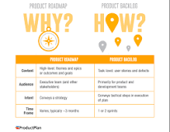
Typical items in a product backlog include user stories, bug fixes, and other tasks. The backlog is a translation of how your team will deliver the vision outlined on an agile road-map. In many ways, it is a giant to-do list for your development team.

Release Backlog
Release Backlog can be defined as the product features which are to be completed within a release cycle. The Scrum Team will identify the User Stories which will go into a specific release and those same user stories will become a part of the Release Backlog.The goal of a given release is to deliver a subset of the product backlog, known as the release backlog. After identifying which user stories will go into a particular release, the user stories become part of a release backlog.
SPRINT
It has a limitation of time, which means that we are limited in time, we have to manage ourselves in time, this time is for four weeks and after that it is completed after a fortnight or four weeks. After that, others start sprinting. For example, if a person walks 1,000 meters and has to cover it in 3 hours, then in two or three hours, he will see how much we have to walk and how many steps to take. If it reaches, I manage that time accordingly
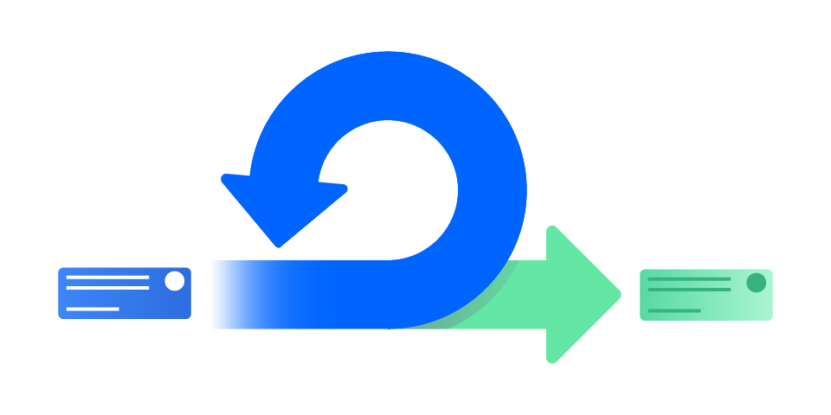
Scrum Sprint
The sprint backlog is a list of tasks identified by the Scrum team to be completed during the Scrum sprint. During the sprint planning meeting, the team selects some number of product backlog items, usually in the form of user stories, and identifies the tasks necessary to complete each user story.
Sprint Backlog
A sprint backlog is a list of work items your team plans to complete during a project sprint. These items are usually pulled from the product backlog during the sprint planning session. A clear sprint backlog prevents scope creep by clarifying exactly what your team will be doing—and not doing—during each sprint.
c) Break Sprint
Breaking the sprint is when the team cannot deliver their commitments at the end of the two weeks. This is sometimes called abnormally terminating. If there are old school developers, you might hear the term abnormal ending or a bending the sprint. Some teams call it blowing up the sprint.
when can you break sprints?
Sprints should only be stopped and thrown out if the goal of the sprint no longer benefits the overall success and completion of the project.

d) Design Sprint Process
Design sprints are an intense 5-day process where user-centered teams tackle design problems. Working with expert insights, teams ideate, prototype and test solutions on selected users. Google's design sprint is the framework to map out challenges, explore solutions, pick the best ones, create a prototype and test it.
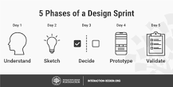
Listed on the sprint backlog
A sprint backlog is a list of work items your team plans to complete during a project sprint. These items are usually pulled from the product backlog during the sprint planning session. A clear sprint backlog prevents scope creep by clarifying exactly what your team will be doing and not doing during each sprint.
7 steps of the design process
- Define the problem. Crucial to solving any design problem is to begin by asking the right questions. ...
- Conduct research. ...
- Brainstorm and conceptualize. ...
- Create a prototype. ...
- Select and finalize. ...
- Product analysis. ...
- Improve.

In successful systems design, three main components must be considered and managed effectively. These are quality, timeliness and cost-effectiveness.
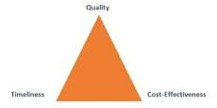
e) Sprint Planning
Sprint planning is limited to a maximum of eight hours. The general rule of thumb is to allow two hours of sprint planning for every one week of sprint length. That means teams should time box sprint planning to four hours for a two-week sprint and eight hours for a one-month sprint.
Long Sprint
Scrum, a sprint is a time-boxed event of one to four weeks in which your Scrum team focuses only on a sprint goal. The goal is typically a product increment or iteration — often an updated, improved version of your product or software
The general rule is that sprint planning should take no more than two hours per week of sprint duration. The following table illustrates the rule.
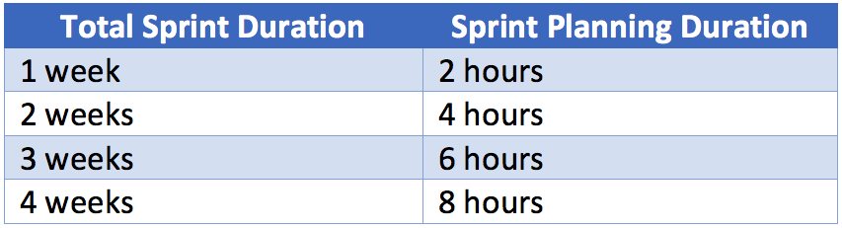
How long should a task planning meeting be for a four week sprint?
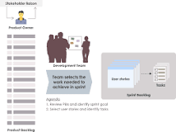
Eight Hours
Each sprint begins with a sprint planning meeting. Typically, for a four-week sprint this meeting should last eight hours. For a two-week sprint, plan for about four hours. As a general rule of thumb, multiply the number of weeks in your sprint by two hours to get your total sprint planning meeting length.

f) DAILY SCRUM
In Daily Scrum it is that we are meeting daily on daily base for about 10 to 15 minutes after that the developer is having a meeting with his team work and then he is discussing that He is discussing about everything informed about this sprint, if something doesn't seem to be implemented, then he does it.

Scrum Meeting
The Scrum of Scrums is a time-boxed session in which a representative from each Team shares high-level updates on their respective team's work and articulates their progress and impediments. Ideally, it should follow the various teams' Daily Stand-ups, so that the latest information is communicated.

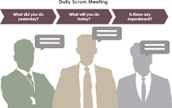
Need of daily scrum
As described in the Scrum Guide, the purpose of the Daily Scrum is to inspect progress toward the Sprint Goal and adapt the Sprint Backlog as necessary, adjusting the upcoming planned work. The Daily Scrum is a 15-minute event for the Developers of the Scrum Team.


g) Sprint Review Meeting
Sprint review has a larger audience, so it's vital that the meeting is planned well and executed well. We will have a look at the planning activities that need to happen before the review meeting. We will also look at the best practices and steps that need to finish during the meeting (execution)

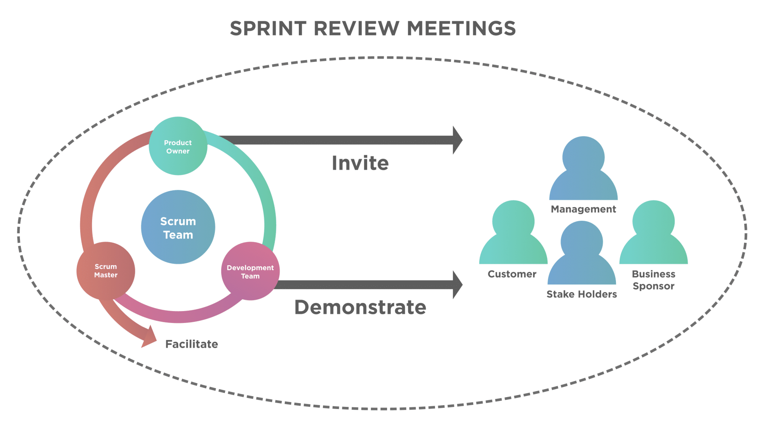

Sprint review is an informal meeting held at the end of the Sprint where the increment is presented to promote the collaboration and obtain the customer’s feedback on the developed product. It is mainly conducted to ‘Inspect’ the Increment and ‘Adapt’ the Product Backlog if required.

Attends the Sprint Review?
The Scrum team and the stakeholders collaborate during a Sprint Review and discuss what was done in the last Sprint and what more changes are required in the product. Based on this review, all the participants collaborate and decide on the things that could be done to get an optimized value.
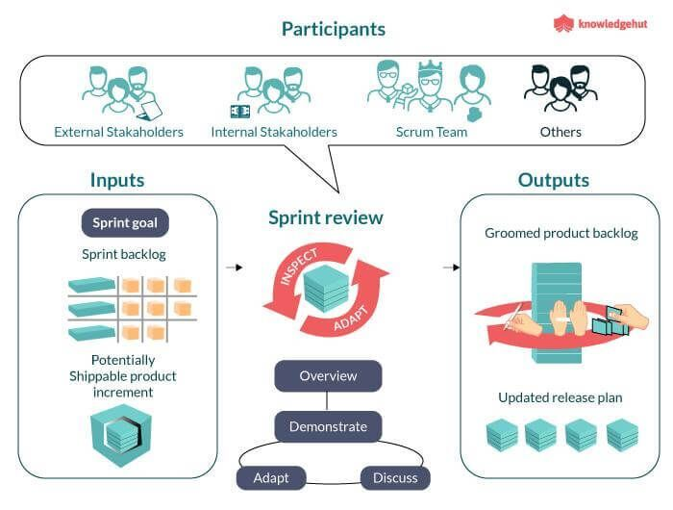
Output Review
keeping all these factors in mind, a revised Product Backlog is the result at the end of the Sprint review. The revised Product Backlog consists of the probable Product Backlog items for the next Sprint. Also, the Product Backlog can be adjusted according to the new market demands
h) SPRINT RETROSPECTIVE IN 6 STEPS
- Use Miro's free retrospective templates. You don't need to start from scratch. ...
- Schedule your sprints. ...
- Invite your team. ...
- Ask the right questions. ...
- Work to improve your processes. ...
- Discuss how it went.

SCRUM PROCESS
